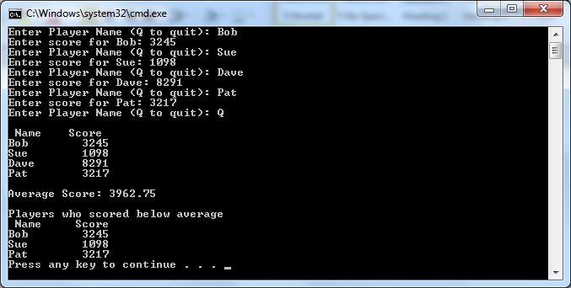

// ---------------------------------------------------------------

// Developer: Kevin Nguyen

// Date Written: June 4, 2015

// Purpose: Video Game Player Program

// ---------------------------------------------------------------

#include<iostream>

#include<iomanip>

#include<string>

usingnamespacestd;

constintArray_Size = 100;

voidInputData(stringPlayerNameArray[], intScoreArray[], int&NumberPlayersRef);

voidDisplayPlayerData(conststringPlayerNameArray[], constintScoreArray[], intNumberPlayers);

doubleCalculateAverageScore(constintScoreArray[], intNumberPlayers);

voidDisplayBelowAverage(conststringPlayerNameArray[], constintScoreArray[], intNumberPlayers, double AverageScore0);

void main()

{

stringPlayerNameArray[Array_Size];

intScoreArray[Array_Size];

intNumberPlayers = 0;

doubleAverageScore;

cout<< fixed <<showpoint<<setprecision(2);

InputData(PlayerNameArray, ScoreArray, NumberPlayers);

DisplayPlayerData(PlayerNameArray, ScoreArray, NumberPlayers);

AverageScore = CalculateAverageScore(ScoreArray, NumberPlayers);

DisplayBelowAverage(PlayerNameArray, ScoreArray, NumberPlayers, AverageScore);

system("pause");

}

voidInputData(stringPlayerNameArray[], intScoreArray[], int&NumberPlayersRef)

{

while(NumberPlayersRef<Array_Size)

{

cout<<"Enter Player Name (Q to quit): ";

getline(cin, PlayerNameArray[NumberPlayersRef]);

if(PlayerNameArray[NumberPlayersRef] == "Q")

break;

cout<<"Enter score for "<<PlayerNameArray[NumberPlayersRef] <<": ";

cin>>ScoreArray[NumberPlayersRef];

cin.ignore(50, '\n');

NumberPlayersRef++;

}

}

voidDisplayPlayerData(conststringPlayerNameArray[], constintScoreArray[], intNumberPlayers)

{

cout<<setw(10) << left <<"\n Name"<<setw(5) << right <<"Score"<<endl;

for(inti = 0; i<NumberPlayers; i++)

cout<<setw(10) << left <<PlayerNameArray[i] <<setw(5) << right <<ScoreArray[i] <<endl;

}

doubleCalculateAverageScore(constintScoreArray[], intNumberPlayers)

{

inti;

doubleAverageScore, TotalScore;

for(i = 0, TotalScore = 0; i<NumberPlayers; i++)

TotalScore += ScoreArray[i];

AverageScore = TotalScore / NumberPlayers;

cout<<"\nAverage Score: "<<AverageScore<<endl<<endl;

returnAverageScore;

}

voidDisplayBelowAverage(conststringPlayerNameArray[], constintScoreArray[], intNumberPlayers, doubleAverageScore)

{

cout<<"Players who scored below average\n";

cout<<setw(10) << left <<" Name"<<setw(5) << right <<"Score"<<endl;

for(inti = 0; i<NumberPlayers; i++)

if (ScoreArray[i] <AverageScore)

cout<<setw(10) << left <<PlayerNameArray[i] <<setw(5) << right <<ScoreArray[i] <<endl;

}

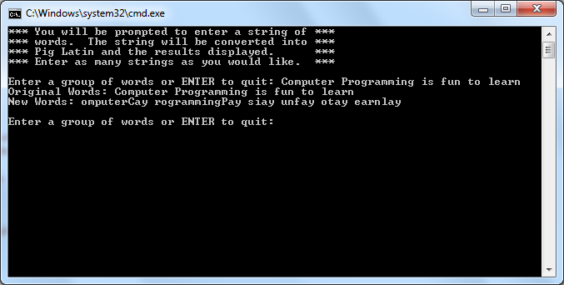

// ---------------------------------------------------------------

// Programming Assignment: LAB5

// Developer: Kevin Nguyen

// Date Written: June 4, 2015

// Purpose: Pig Latin Program

// ---------------------------------------------------------------

#include<iostream>

#include<string>

usingnamespacestd;

stringpigLatinString(stringpStr);

void main ()

{

stringstr;

cout<<"*** You will be prompted to enter a string of ***\n";

cout<<"*** words. The string will be converted into ***\n";

cout<<"*** Pig Latin and the results displayed. ***\n";

cout<<"*** Enter as many strings as you would like. ***\n";

while(true)

{

cout<<"\nEnter a group of words or ENTER to quit: ";

getline(cin, str);

if(str.length() == 0)

break;

cout<<"Original Words: "<<str<<endl;

cout<<"New Words: "<<pigLatinString(str) <<endl;

}

system("pause");

}

stringpigLatinString(stringpStr)

{

string::size_typelen;

string::size_type counter;

string::size_type start = 0;

string::size_type begin = 0;

string word, newString = "";

while(true)

{

start = pStr.find(' ', start);

if(start == string::npos) break;

word = pStr.substr(begin, start - begin);

newString += word.substr(1) + word.substr(0, 1) + "ay ";

start++;

begin = start;

}

word = pStr.substr(begin, pStr.length() - begin);

newString += word.substr(1) + word.substr(0, 1) + "ay";

returnnewString;

}